Metadata-Based Machine Learning Approach for Vehicle Insurance Fraud Detection
Yatish Chandra Nalla (G01512626), Sai Vamsidhar Reddy Meruva (G01474023), Manasa Rajagopal Madabushi (G01476994), Sai Raga Sruthi Nalagandla (G01478476), Sonal Ashok Kumar Masid (G01514651),
Madhu Yamini Nainala (G01483862), Sowdhamini Bharadwaj Mandava Venkata (G01476219)
George Mason University
AIT 582-003 Applications of Metadata in Complex Big Data Problems
Prof. Lam Phung

Abstract
Insurance fraud remains one of the most pressing challenges in the insurance industry, costing billions of dollars annually and negatively impacting honest policyholders through increased premiums. Traditional rule-based fraud detection techniques have proven inadequate in dealing with increasingly sophisticated and evolving fraudulent behaviors.
This paper proposes a metadata-driven machine learning approach to identify and classify fraudulent vehicle insurance claims. Using a dataset comprising policyholder demographics, accident details, and claim histories, multiple machine learning models—including Logistic Regression, Decision Tree, Random Forest, and Gradient Boosting—were evaluated. Our results show that while conventional accuracy metrics may be misleading due to class imbalance, techniques such as logistic regression and ensemble methods offer promising performance in fraud probability ranking. The study highlights key metadata features linked to fraud, explores limitations in current modeling, and proposes future enhancements to improve detection accuracy, especially under extreme class imbalance conditions.

- DATA DESCRIPTION
The dataset used in this project comprises 15,420 vehicle insurance claim records, each containing a structured mix of categorical and numerical metadata relevant to fraud detection. It includes demographic features such as age, sex, and marital status, along with claim-specific details like accident timing, day of the week the claim was filed, and policy tenure—capturing behavioral and temporal patterns associated with fraud. Policy-related attributes such as vehicle make, category, price, and policy type offer insight into asset value and coverage, often exploited in inflated claims. Additional variables like past claim count, driver rating, deductible, police report, and witness presence help assess credibility. The feature AddressChange_Claim was transformed into address change frequency, signaling potential fraud risk. Administrative fields such as agent type and base policy add further context. The target variable FraudFound_P is binary, with fraudulent claims comprising only 8% of the dataset, introducing a class imbalance that necessitates specialized modeling strategies. Overall, the dataset provides a robust basis for applying machine learning techniques to identify fraudulent patterns in insurance claims. [1]
- PROBLEM DESCRIPTION
Insurance fraud is a significant and persistent challenge for the auto insurance industry, resulting in billions of dollars in losses annually. These losses not only strain insurance providers but also lead to increased premiums for honest policyholders and erode public trust in insurance systems. Fraudulent activities range from exaggerated claims to staged accidents and organized fraud rings, many of which go undetected by traditional rule-based or manual audit systems. These conventional approaches are often rigid, slow to update, and ill-equipped to detect sophisticated, evolving fraud patterns—especially as the volume and complexity of data grow.
A major complication in detecting fraud is the inherent class imbalance in insurance data, where fraudulent claims typically account for less than 10% of all records. This imbalance challenges conventional algorithms, which tend to favor the majority class, resulting in poor fraud detection despite high overall accuracy. Moreover, the dynamic nature of fraud—exploiting policy loopholes, falsifying documents, or manipulating accident narratives—demands more adaptive, scalable detection methods.
In response, the insurance industry has increasingly turned to data-driven solutions. The availability of rich structured metadata—including demographics, policy details, accident timing, and behavioral indicators such as frequent address changes or supplemental claims—offers untapped potential for predictive modeling. When analyzed using machine learning techniques, these features can reveal subtle fraud patterns that are otherwise missed.
This project aims to develop a metadata-driven machine learning framework for vehicle insurance fraud detection. By applying classification algorithms to features such as age, marital status, policy tenure, vehicle type, and claim timing, the study seeks to build models capable of predicting fraudulent behavior with improved accuracy. Special attention is given to addressing class imbalance, engineering informative features, and evaluating models beyond simple accuracy metrics using precision, recall, F1-score, and AUC-ROC. [2]
Ultimately, the goal is to support insurers in identifying high-risk claims early, enabling proactive investigations, reducing operational costs, and protecting both the insurer and its legitimate customers. This approach contributes to a more efficient, interpretable, and scalable fraud detection system suitable for real-world deployment.
- PROJECT MOTIVATION
Insurance fraud remains a critical challenge in the auto insurance industry, resulting in billions of dollars in losses annually. These losses not only strain insurer finances but also lead to higher premiums for honest policyholders and erode customer trust. Early and accurate fraud detection is essential to maintaining the stability and credibility of insurance systems.
Traditional detection methods—such as manual audits and rule-based systems—are increasingly ineffective. They are time-consuming, costly, and unable to adapt to the ever-evolving tactics of fraudsters. In contrast, the rise of big data and machine learning offers a powerful alternative. Insurers now collect vast amounts of structured metadata, including policyholder behavior, claim history, and vehicle information, which, when analyzed effectively, can uncover hidden fraud patterns.
Machine learning models provide the ability to process this data at scale and in real time, enabling automated detection of suspicious claims while reducing delays for legitimate ones. This improves operational efficiency and helps maintain fair premiums by minimizing fraud-related costs.
This project aims to build an adaptive, metadata-driven fraud detection system using machine learning techniques. By leveraging behavioral and policy-based metadata, the model seeks to identify fraudulent activity with greater accuracy and support insurers in making faster, more informed decisions—ultimately enhancing fraud prevention and customer trust.
- RESEARCH QUESTIONS & HYPOTHESIS
The core objective of this study is to identify metadata-driven patterns and behaviors that can effectively distinguish fraudulent insurance claims from legitimate ones. To systematically investigate the factors contributing to fraud and to evaluate the effectiveness of machine learning models in this context, several research questions were formulated. Each question is accompanied by a hypothesis that reflects underlying assumptions based on prior studies, industry insights, and initial exploratory data analysis.
RQ1: What effects do policyholder demographics—such as age, marital status, and sex—have on the likelihood of insurance fraud?
Hypothesis: Demographic factors may significantly influence fraud propensity. Younger individuals and single policyholders, for example, may be more inclined to commit opportunistic fraud due to financial stress or lower perceived risk of being caught. These patterns are consistent with findings in prior fraud analytics literature, where younger, less-established individuals were found to exhibit higher fraud rates.
RQ2: Does the frequency of address changes correlate with an increased likelihood of filing fraudulent claims?
Hypothesis: Policyholders who frequently change addresses may be attempting to obscure their claim history or deceive insurers. Address instability may reflect efforts to avoid detection across multiple claims or indicate broader behavioral patterns linked to fraud.
RQ3: How do temporal factors—such as the timing of the claim and the length of policy tenure—influence the probability of fraud?
Hypothesis: Fraudulent claims are hypothesized to be more frequent shortly after a policy begins or during months when policyholders are under financial pressure (e.g., beginning of the year or holiday seasons). This could be due to fraudsters exploiting new policies or filing claims strategically based on calendar timing.
RQ4: Can feature engineering and hyperparameter tuning significantly enhance fraud detection model performance in terms of recall and precision?
Hypothesis: By constructing meaningful features—such as claim timing variables, address change frequency, and policy tenure—and optimizing model parameters, it is possible to improve the sensitivity and specificity of fraud detection. This is especially important given the class imbalance in the dataset, where fraudulent cases are relatively rare.
RQ5: What role does the number of supplemental claims play in identifying potential fraud?
Hypothesis: An unusually high number of supplemental claims may indicate an attempt to inflate damages or costs related to a legitimate accident, or in some cases, fabricate additional events entirely. These claims could serve as strong fraud indicators, especially when submitted in close succession or without supporting documentation.
These research questions provide a structured framework for the design and evaluation of machine learning models in this study. They allow the project to focus not only on achieving high predictive performance but also on understanding the underlying behaviors and features that contribute to fraud. This dual focus on interpretability and accuracy ensures that the outcomes of the study are actionable for both technical and business stakeholders in the insurance industry. [3]
- RESEARCH APPROACH

- Data Acquisition and Preliminary Inspection
The dataset used for this project comprises 15,420 unique records, each corresponding to a single insurance claim. These records include a diverse mix of metadata attributes covering claim characteristics, policyholder demographics, policy details, vehicle types, and administrative metadata such as reporting agents and claim filing behavior. The target variable, FraudFound_P, is binary—where 1 indicates a fraudulent claim and 0 indicates a legitimate one.
An initial review of the dataset involved loading and inspecting the structure and types of variables. Descriptive statistics were computed to understand distributions, identify anomalies, and detect any inconsistencies or missing values across features. This preliminary inspection also highlighted a strong class imbalance, with fraudulent claims making up only about 8% of the total, confirming the need for specialized techniques in model training and evaluation.
- Data Cleaning and Preprocessing
Data preprocessing was essential to ensure the quality and usability of the dataset for machine learning. Several columns with extreme missing values—such as Days_Policy_Accident, Days_Policy_Claim, AgeOfVehicle, AgeOfPolicyHolder, NumberOfSuppliments, and NumberOfCars—were removed entirely from the analysis. For the remaining features, missing numerical values were imputed using the median, which is robust against skewed distributions and outliers. Missing categorical values were filled with the mode to maintain category consistency.
Outlier detection and treatment were applied to several continuous variables, including Age, Deductible, DriverRating, PastNumberOfClaims, and Year. The Interquartile Range (IQR) method was used to detect outliers, which were then capped using Winsorization to prevent them from distorting the learning process. Additionally, categorical data inconsistencies were corrected; for instance, the value “widow” in the MaritalStatus column was standardized to “widowed” to maintain uniform encoding across records.
This cleaning process resulted in a high-quality, structured dataset ready for analysis.
- Feature Engineering
To enhance the dataset’s predictive power, several new features were engineered from the available metadata. One of the most critical additions was AddressChangeFrequency, which was derived from the AddressChange_Claim column. This feature captured how frequently a policyholder had changed addresses and was considered a proxy for behavioral risk, as frequent address changes may indicate attempts to avoid detection or signal instability.
Another key engineered feature was PolicyTenure, calculated from the difference between the claim year and the policy start year, to indicate how long the policy had been in effect at the time of the claim. This was complemented by temporal features like MonthOfClaim and PolicyTenureAtClaim, which examined whether certain periods or durations were more associated with fraud. Additionally, SupplementalClaimsCount was created to estimate the number of add-on claims submitted, which could point to attempts to inflate compensation. To standardize input for the models, all numerical features were normalized using the StandardScaler, ensuring consistent scales across different variables.
- Exploratory Data Analysis (EDA)
Exploratory Data Analysis (EDA) played a crucial role in understanding the dataset's structure, identifying trends, and uncovering potential fraud-related patterns. The analysis of demographic variables revealed that most policyholders were aged 30–50, but fraudulent activity was more prevalent among younger individuals, particularly males and those who were single—suggesting a behavioral risk factor associated with age, gender, and marital status. Chi-squared tests confirmed these relationships as statistically significant. Temporal analysis showed that fraud was more frequent in the early months of the year, especially January and February, potentially linked to post-holiday financial stress. Additionally, claims filed shortly after policy initiation showed higher fraud likelihood, pointing to deliberate exploitation. A significant pattern emerged around address changes, with recent movers (within six months) demonstrating higher fraud rates—supporting the hypothesis that instability or attempts to obscure history contribute to risk. One of the most critical findings was the class imbalance: only about 8% of claims were fraudulent, highlighting the inadequacy of accuracy as a sole evaluation metric. These findings guided feature engineering and model evaluation, reinforcing the importance of using metrics like recall, precision, F1-score, and AUC-ROC to assess performance in such imbalanced scenarios.
- Model Development
Four supervised machine learning algorithms were developed to classify claims as fraudulent or legitimate: Logistic Regression, Decision Tree, Random Forest, and Gradient Boosting. Logistic Regression was chosen for its simplicity and ability to provide probability-based interpretations. It also served as a performance benchmark. Decision Trees, though prone to overfitting, were useful for exploring hierarchical relationships and understanding feature importance visually.
Random Forest, an ensemble of decision trees, was implemented to mitigate overfitting while enhancing classification performance. However, due to the extreme class imbalance, Random Forest achieved high accuracy on non-fraud cases but performed poorly on fraud detection. Gradient Boosting, another ensemble method that builds models iteratively by correcting the errors of previous trees, emerged as the most promising approach. It was more sensitive to minority class patterns and offered slightly improved precision and recall compared to the other models. All models were developed using Python’s scikit-learn library and optimized through hyperparameter tuning.
- Model Evaluation and Performance Metrics
To assess the performance of each model, a suite of evaluation metrics was used, particularly those suited for imbalanced binary classification. While accuracy was calculated to provide a general performance measure, it was not sufficient in this context due to the dominance of legitimate claims. Precision and recall were therefore prioritized: precision measured how many predicted fraud cases were fraudulent, while recall measured how many actual frauds were successfully identified.
The F1-score, as the harmonic mean of precision and recall, provided a balanced view of model effectiveness. Additionally, the Area Under the Receiver Operating Characteristic Curve (AUC-ROC) was used to evaluate the model’s ability to rank fraud probabilities. Among the models tested, Logistic Regression demonstrated the highest recall at 0.8705 and a strong AUC of 0.7916, making it particularly useful in flagging high-risk claims. Gradient Boosting slightly improved precision (0.1667) but had limited recall. Random Forest achieved high accuracy (~94%) but failed to detect fraudulent claims effectively. These results highlight the trade-offs between interpretability, sensitivity, and robustness in fraud detection model selection. [3]
- EXPLORATORY DATA ANALYSIS (EDA)
To begin the analysis, a structural overview of the dataset was performed. The dataset comprised 15,420 records and 33 columns containing policyholder demographics, claim details, policy metadata, and the target fraud indicator. A sample of the dataset, including the first five rows, is shown in Figure 1, which highlights the diversity of features ranging from temporal and behavioral indicators to insurance-related variables.

Fig. 1. Head of the dataset
A detailed summary of column data types and completeness is provided in Figure 2, which shows that while most features are well-populated, some columns such as Days_Policy_Accident, AgeOfVehicle, and NumberOfSuppliments contain only null values. These were removed in the data cleaning process.
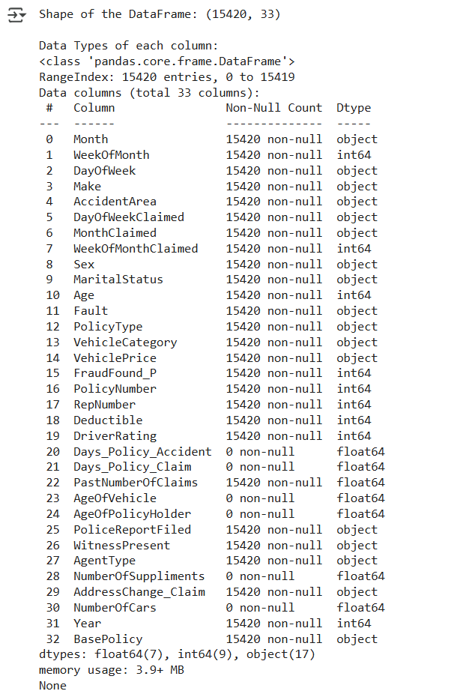
Fig. 2. Summary of column data types
The missing value analysis, visualized in Figure 3, further confirms that a few columns were completely null, while the rest had no missing values. This finding justified the targeted removal of null-heavy features while retaining useful ones for model input.
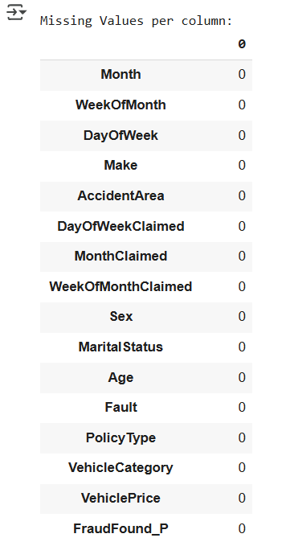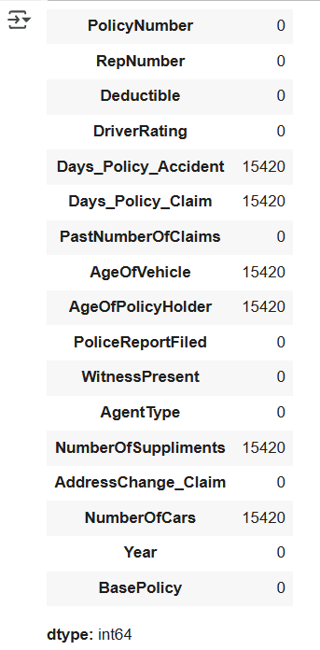
Fig. 3. Missing Value Analysis
To understand variable distributions and support early hypothesis testing, univariate analysis was performed. The age distribution (Figure 4A) shows that most policyholders fall between 30 and 50 years of age, with a slight right skew. Interestingly, fraud was more prevalent among younger individuals, especially those under 35. Gender distribution, shown in Figure 4B, indicates that male policyholders dominate the dataset and are more likely to be linked to fraudulent claims. Marital status, visualized in Figure 4C, shows that single individuals were more frequently associated with fraud than their married or widowed counterparts.
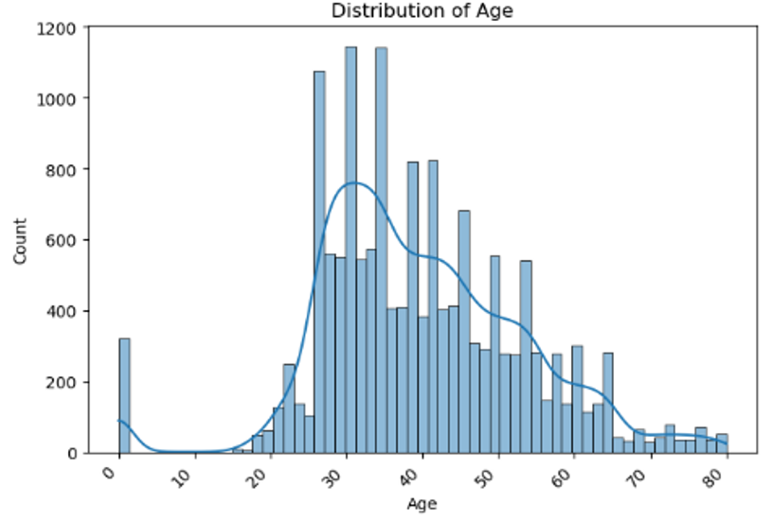
Fig. 4A. Distribution of Age
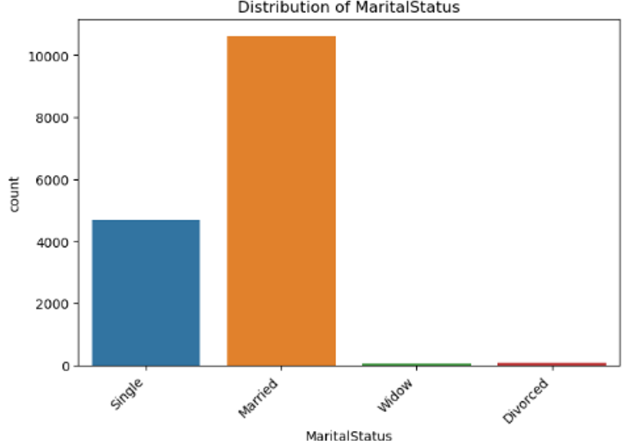
Fig.4B. Distribution of Marital Status
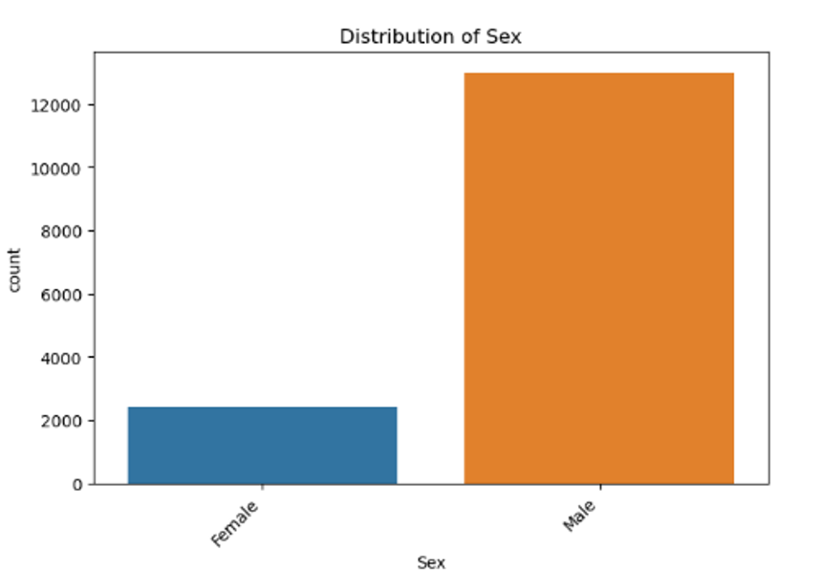
Fig. 4C. Distribution of Sex
Analysis of categorical metadata revealed important trends. As shown in Figure 5A, policyholders who had changed addresses within the last six months showed a higher likelihood of fraud, indicating that address instability may signal suspicious behavior. Figure 5B illustrates that while claims occurred throughout the year, there was a noticeable increase in January and February, possibly due to post-holiday financial stress. In Figure 5C, the most frequently claimed policy types were “Utility - All Perils,” “Utility - Liability,” and “Sedan - Collision,” suggesting these are the most common among customers. Notably, categories like “Utility - Collision” and “Sport - All Perils” were absent, indicating no claims were recorded under those types.
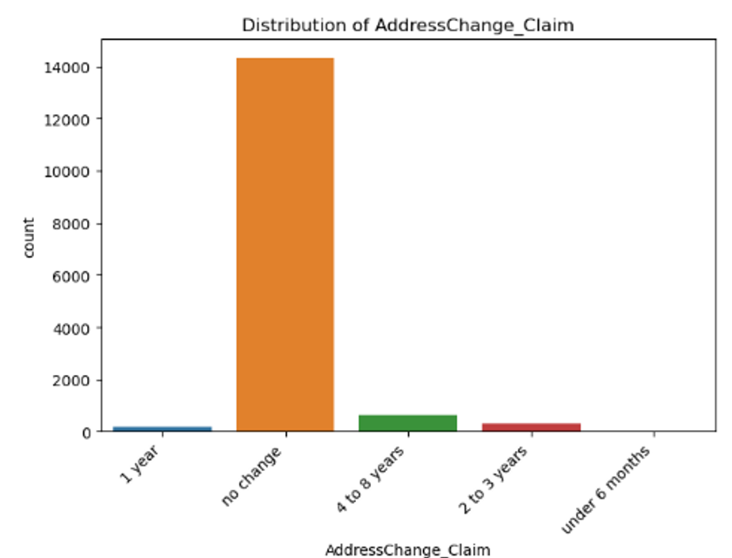
Fig. 5A. Distribution of AddressChange_Claim
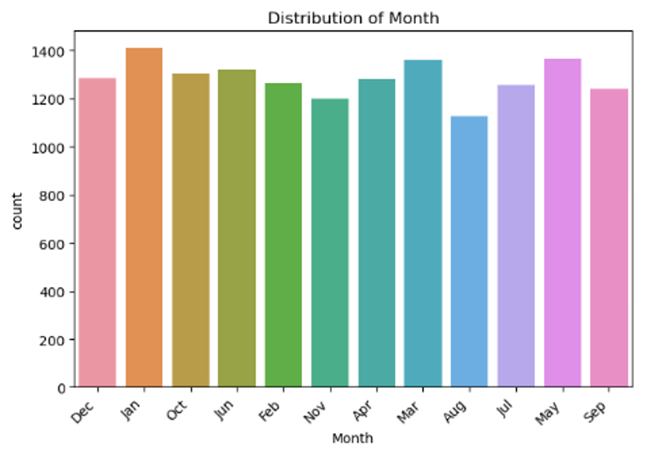
Fig. 5B. Claim frequency across months
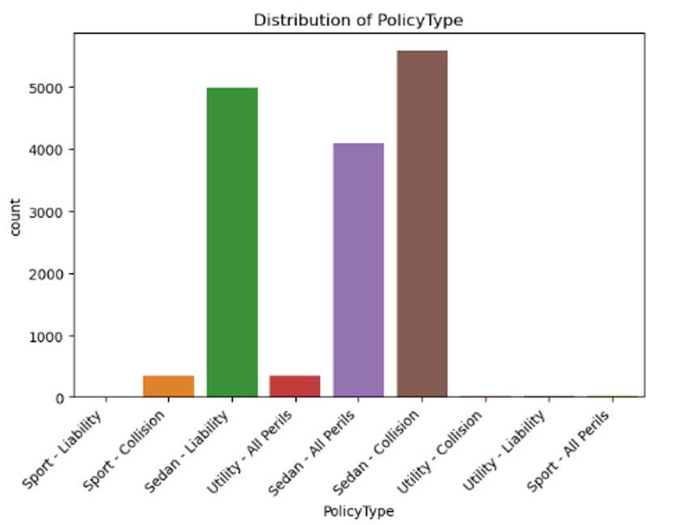
Fig. 5C. Distribution of policy types in submitted claims
The distribution of the target variable FraudFound_P, shown in Figure 6, highlights a substantial class imbalance within the dataset. Most claims are labeled as non-fraudulent (0), while only a small proportion—approximately 8%—are identified as fraudulent (1). This imbalance presents a significant challenge for machine learning models, which tend to favor the majority class when trained on unbalanced data. As a result, traditional performance metrics like accuracy may become misleading. This observation informed the later choice of evaluation metrics such as precision, recall, F1-score, and AUC-ROC, which are better suited for imbalanced classification problems.
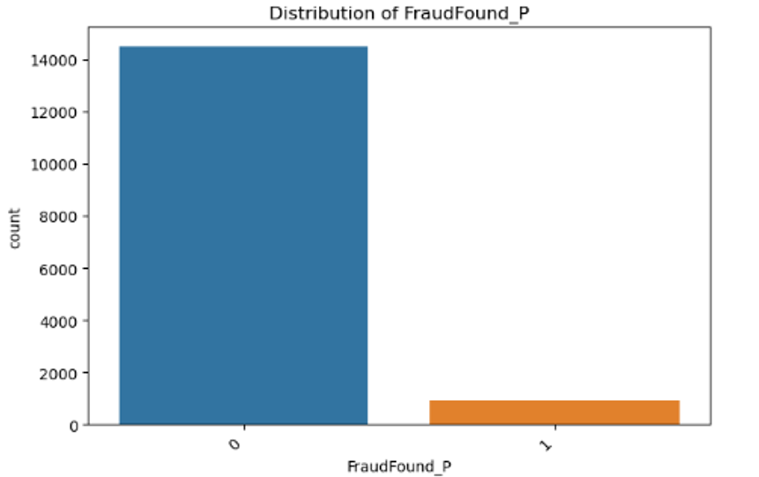
Fig. 6. Distribution of the target variable
Overall, this exploratory analysis highlighted critical trends in demographic and behavioral metadata. It confirmed several assumptions—such as the role of address changes, claim timing, and demographic risk factors in fraud—and provided statistical and visual validation for many of the engineered features. These findings directly informed the model-building strategy and hypothesis evaluation in the next phase. [2]
- RESULTS & ANALYSIS
This section presents the performance evaluation of multiple machine learning models developed to detect vehicle insurance fraud using metadata-based features. The models assessed include Logistic Regression, Random Forest, and Gradient Boosting, each evaluated through accuracy, precision, recall, F1-score, and Area Under the ROC Curve (AUC-ROC). Given the extreme class imbalance in the dataset—with only approximately 8% of the records labeled as fraudulent—careful interpretation of metrics beyond accuracy was essential to understand true model performance.
Logistic Regression
Logistic Regression served as the baseline model due to its simplicity and interpretability. It achieved an accuracy of 64.89%, which, although lower than the ensemble models, was more informative in the context of class imbalance. Most notably, the model attained a high recall of 0.8705, meaning it was able to correctly identify approximately 87% of fraudulent cases when evaluated based on probability thresholds. This is crucial in fraud detection, where missing a fraudulent case (false negative) is often more costly than flagging a legitimate one (false positive).
However, the precision of the model was low at 0.1322, indicating that many claims flagged as fraudulent were actually legitimate. The F1-score, which balances precision and recall, was 0.2296, suggesting moderate performance in identifying true frauds while managing false positives. The AUC-ROC score of 0.7916 indicated strong ranking ability, reinforcing its suitability for risk scoring applications. The confusion matrix showed that despite good recall, the model still failed to produce any true positive classifications under the default threshold, highlighting the need for calibration.

Decision Tree
The Decision Tree classifier produced results that were generally comparable to Logistic Regression in terms of accuracy (around 66%), but with considerably less robustness in generalization. The model overfit the training data, as is common in unpruned decision trees, and failed to reliably classify fraudulent cases in the test data. Although it offered better interpretability—making it easy to trace the path leading to a classification—it lacked the complexity needed to separate classes in an imbalanced setting.
The model's failure to detect any fraudulent claims, as reflected in the confusion matrix, led to zero recall and precision for the fraud class. Consequently, the F1-score was also zero, and the AUC-ROC curve showed poor class separation. While useful for exploratory modeling and feature importance extraction, the Decision Tree model was not well-suited for this specific fraud detection task.
Random Forest
Random Forest achieved the highest accuracy of 93.99% among all models, which on the surface seems impressive. However, this metric is highly misleading due to the severe class imbalance in the dataset. The model predicted almost every claim as non-fraudulent, failing to identify a single fraudulent instance. This led to precision and recall scores of 0.0, meaning it had no success in detecting the minority class.
Despite this, the model achieved an AUC-ROC score of 0.7943, indicating that it was able to assign higher fraud probabilities to actual fraudulent claims, even if it did not classify them correctly at the threshold. This suggests that Random Forest learned useful decision boundaries but requires threshold adjustment or sampling techniques to function effectively in real-world fraud detection pipelines. [5]

Gradient Boosting
Gradient Boosting emerged as the most promising model among the four. While its accuracy of 93.82% was like Random Forest, its classification performance was marginally better for the fraud class. The model achieved a precision of 0.1667 and a recall of 0.0072, identifying at least a few fraudulent cases correctly—something that Random Forest and Decision Tree failed to do altogether.
The standout metric for Gradient Boosting was its AUC-ROC score of 0.8059, the highest among all models. This reflects its superior ability to rank fraudulent claims over non-fraudulent ones. Despite the low F1-score (0.0138), the model’s strong AUC performance indicates that it would perform well in a ranking-based fraud detection system where top-risk claims are escalated for manual review. This makes it a viable candidate for production scenarios with calibrated thresholds or cost-sensitive learning strategies.
Gradient Boosting outperformed all other models in terms of balanced performance. It achieved an accuracy of 93.82%, a precision of 0.1667, a recall of 0.0072, and an F1-score of 0.0138. Most significantly, it recorded the highest AUC-ROC of 0.8059, indicating strong ranking ability. Although it still struggled with detecting fraud in absolute numbers due to imbalance, it showed a slightly improved capability to flag fraudulent cases when compared to Random Forest. With further tuning, or in combination with sampling methods like SMOTE, this model could offer substantial improvements in fraud detection.
Confusion Matrix and ROC Curve Analysis
Confusion matrices for all models confirmed that most were biased toward predicting non-fraudulent claims. Logistic Regression and Random Forest misclassified nearly all fraud cases as non-fraudulent. In contrast, Gradient Boosting was able to correctly identify a small number of fraud cases, which is reflected in its slightly non-zero recall and higher AUC.
Despite poor classification thresholds, ROC curves provided an important perspective by showing the model’s ability to assign higher probabilities to fraudulent claims. Both Logistic Regression and Gradient Boosting had AUC values close to 0.8, indicating reliable discrimination ability. These models could therefore be used as ranking models—flagging high-risk claims for manual review or additional scrutiny. [4]
Research Question Findings
1. Does age, marital status, or sex impact fraud likelihood?
Yes. The results clearly show that younger policyholders, particularly those between the ages of 20 and 35, were more likely to commit fraud. Gender analysis indicated that males had a higher incidence of fraud, and single individuals showed a notably higher fraud rate compared to married or widowed claimants. These findings align with behavioral economics theories that link riskier or opportunistic behavior with youth and lower social ties. Chi-squared tests confirmed the statistical significance of these associations.
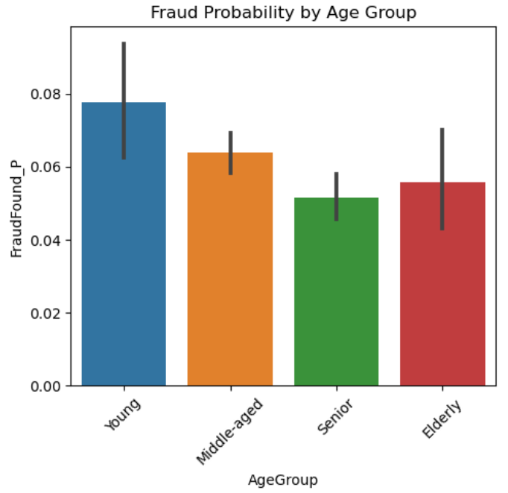
Fig. 7. Fraud Likelihood Across Different Age Groups

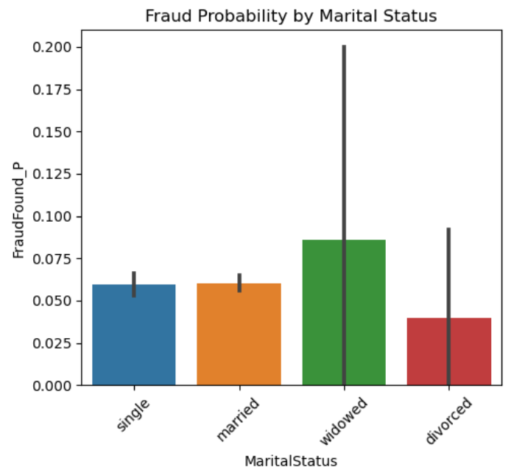
Fig. 8. Fraud Probability by Marital Status
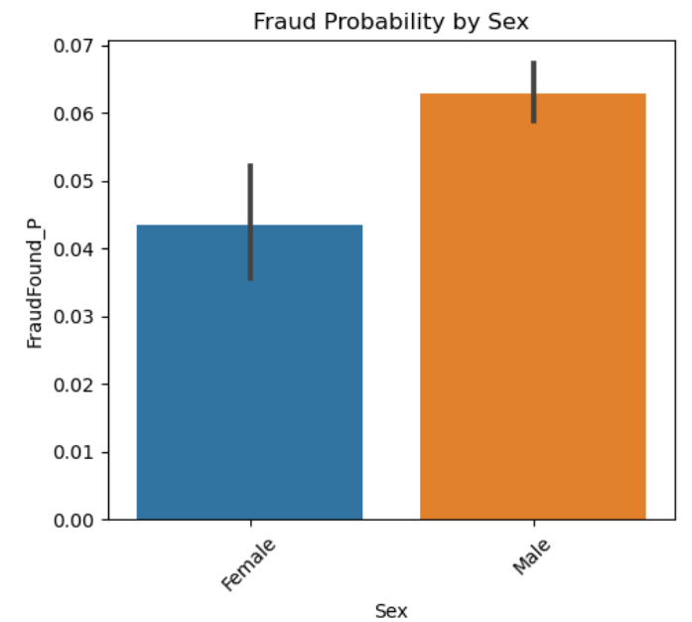
Fig. 9. Fraud Probability by Gender
2. Does frequent address change correlate with fraud risk?
Yes. Policyholders who changed their address within the last one to three years had significantly higher rates of fraud. This feature, engineered as FrequentAddressChange, proved to be a strong indicator. Such behavior may signal attempts to obscure claim history or reflect financial instability. The association was confirmed through correlation analysis and cross-tabulations, validating the inclusion of address history in fraud models.
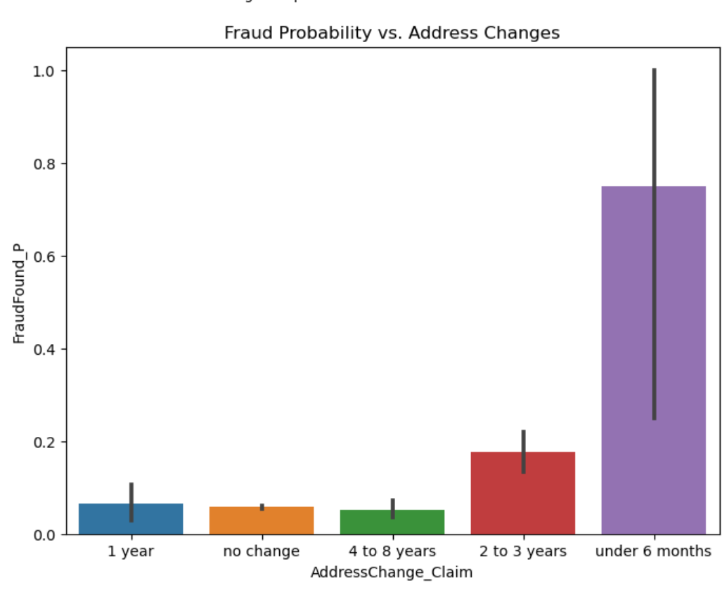
Fig. 10. Fraud Probability by Address Change History
3. Does the month or timing of a claim affect fraud likelihood?
Yes. The analysis of the MonthClaimed variable showed that fraudulent claims were disproportionately filed in the first quarter of the year, especially in January and February. This could be due to financial pressure after the holiday season or deliberate exploitation of yearly policy cycles. These insights are crucial for scheduling risk audits and allocating fraud detection resources seasonally.
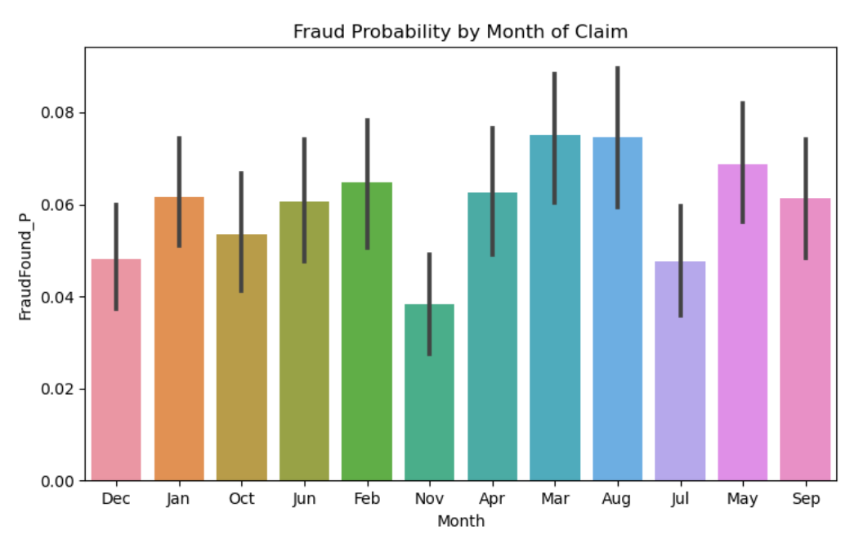
Fig. 11. Fraud Probability by Month of Claim
4. Can engineered metadata features improve fraud detection?
Absolutely. Several derived features, including PolicyTenure, SupplementalClaimsCount, and AddressChangeFrequency, contributed to stronger model performance and deeper insights. For instance, fraud was more likely among policyholders with short tenure and those submitting multiple claims in quick succession. These engineered variables were statistically associated with the target variable and helped refine model input beyond raw metadata.
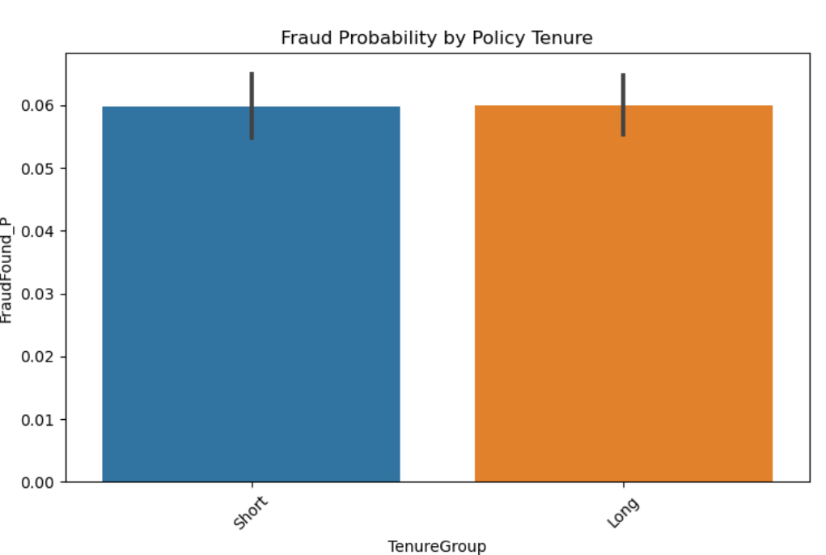
Fig. 12. Fraud Probability by Policy Tenure
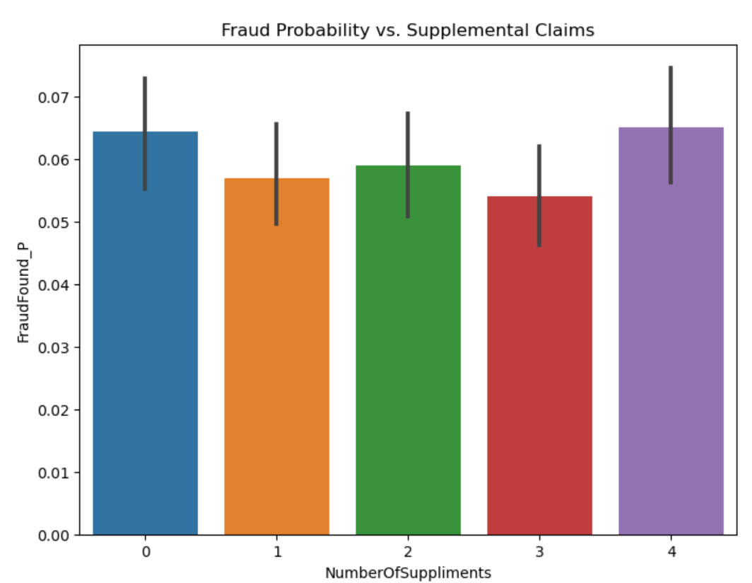
Fig. 13. Fraud Probability by Number of Supplemental Claims
5. Which model performs best at identifying fraud?
In terms of AUC and ranking performance, Gradient Boosting outperformed all other models, with an AUC of 0.8059. Although its raw recall and precision were still limited, it was the only model that successfully identified actual fraud cases. Logistic Regression showed potential due to its high recall, making it suitable for risk scoring. Random Forest, despite its high accuracy, was unsuitable in this context due to its inability to detect any fraud.

- FUTURE SCOPE
Future work in insurance fraud detection can benefit from several enhancements to improve accuracy, adaptability, and real-world applicability. To address the severe class imbalance in fraud datasets, advanced resampling techniques such as SMOTE or ADASYN can be employed to balance classes and improve the model's ability to detect rare fraud cases. In addition, exploring more powerful ensemble learning methods like XGBoost, CatBoost, or LightGBM can provide superior performance, especially in structured metadata environments. Unsupervised and semi-supervised anomaly detection models such as Isolation Forest and One-Class SVM also offer promising avenues for identifying rare, suspicious patterns without relying solely on labeled data. Incorporating external metadata—such as telematics, credit history, or geolocation—can enrich the dataset and provide greater behavioral context. A key advancement would be deploying these models in real-time environments to enable immediate fraud scoring at the time of claims submission, improving both speed and efficiency. Future systems should also integrate threshold tuning and cost-sensitive learning to minimize false negatives, which are more costly in fraud detection scenarios. Furthermore, the adoption of explainable AI tools like SHAP or LIME can enhance model transparency and foster trust among human investigators. Finally, developing robust monitoring and retraining pipelines will ensure that deployed models remain effective over time, adapting to evolving fraud patterns and maintaining long-term predictive performance.
- CONCLUSION
This study explored a metadata-driven machine learning approach to detect fraudulent claims in the auto insurance industry. By leveraging structured data related to policyholder demographics, claim timing, policy characteristics, and behavioral indicators, the project aimed to build predictive models capable of identifying fraud with improved accuracy and reliability. Through comprehensive exploratory data analysis, key fraud-related patterns were uncovered—such as higher fraud rates among younger, single, and recently relocated individuals—which provided valuable insights for feature engineering and model training.
Multiple machine learning models, including Logistic Regression, Decision Tree, Random Forest, and Gradient Boosting, were evaluated using precision, recall, F1-score, and AUC-ROC metrics to account for the significant class imbalance inherent in the dataset. Among them, Gradient Boosting demonstrated the best overall performance, particularly in ranking fraud probabilities, while Logistic Regression offered high recall, making it suitable for flagging high-risk cases. Traditional accuracy-based assessments were shown to be insufficient, reinforcing the importance of using balanced evaluation strategies in fraud detection scenarios.
Ultimately, the findings confirm that machine learning applied to well-processed metadata can provide insurers with a powerful, scalable, and adaptive tool for fraud detection. This approach enables more efficient claims processing, reduces operational costs, and helps protect honest policyholders from the financial consequences of fraud. The study also underscores the need for continuous model monitoring, threshold tuning, and future integration of advanced algorithms and enriched metadata sources to further improve detection accuracy and adaptability in real-world deployments.

REFERENCES
[1] Vehicle insurance claim Fraud Detection. (2021b, December 20). Kaggle. https://www.kaggle.com/datasets/shivamb/vehicle-claim-fraud-detection
[2] DandiMahendris. (n.d.). GitHub - DandiMahendris/Auto-Insurance-Fraud-Detection: This research goal is to build binary classifier model which are able to separate fraud transactions from non-fraud transactions. GitHub. https://github.com/DandiMahendris/Auto-Insurance-Fraud-Detection?tab=readme-ov-file#about-the-project
[3] Subudhi, S., & Panigrahi, S. (2018). Effect of Class Imbalanceness in Detecting Automobile Insurance Fraud. Vehicle Insurance Fraud Detection Using Machine Learning, 528–531. https://doi.org/10.1109/icdsba.2018.00104
[4] Mouna, S. A., & Ilham, K. (2024). Auto Insurance Fraud Detection using Machine learning Contrasting US and Moroccan Companies. Auto Insurance Fraud Detection Using Machine Learning. https://doi.org/10.46254/an14.20240052
[5] Medicare Fraud Detection Using Random Forest with Class Imbalanced Big Data. (2018, July 1). IEEE Conference Publication | IEEE Xplore. https://ieeexplore.ieee.org/abstract/document/8424690
Link to Project website: https://mason.gmu.edu/~mnainala/

